**Department of Computer Science and Engineering**

**National Institute of Technology, Hamirpur**

**Name: Manas Gupta**

**Roll Number: 21BCS010**

**Digital Image Processing CS-325**

**Solution Laboratory Assignment -1**

**Topic: Spatial Image Enhancement functions and interpretation of results**

Solution 1:

*from* PIL *import* Image

*import* numpy *as* np

*import* matplotlib.pyplot *as* plt

def read_bmp(*file_path*):

image = Image.open(*file_path*)

*return* image

def intensity_averaging(*image*):

*return* *image*.convert('L')

def intensity_inversion(*image*):

*return* Image.fromarray(255 - np.array(*image*))

def sub_sampling(*image*, *factor*):

width, height = *image*.size

new_width, new_height = width // *factor*, height // *factor*

*return* *image*.resize((new_width, new_height))

def main():

*# Replace 'input.bmp' with the path to your BMP file*

file_path = 'MRIspineFracture.bmp'

*# Read the BMP file*

original_image = read_bmp(file_path)

*# Perform intensity averaging*

averaged_image = intensity_averaging(original_image)

*# Perform intensity inversion*

inverted_image = intensity_inversion(original_image)

*# Perform sub-sampling with factor 2*

subsampled_image = sub_sampling(original_image, *factor*=2)

*# Display the images*

plt.figure(*figsize*=(10, 5))

plt.subplot(2, 3, 1)

plt.imshow(original_image)

plt.title('Original Image')

plt.subplot(2, 3, 2)

plt.imshow(averaged_image, *cmap*='gray')

plt.title('Intensity Averaging')

plt.subplot(2, 3, 3)

plt.imshow(inverted_image, *cmap*='gray')

plt.title('Intensity Inversion')

plt.subplot(2, 3, 4)

plt.imshow(original_image)

plt.title('Original Image')

plt.subplot(2, 3, 5)

plt.imshow(subsampled_image)

plt.title('Sub-sampling (Factor 2)')

plt.tight_layout()

plt.show()

*if* __name__ == "__main__":

main()

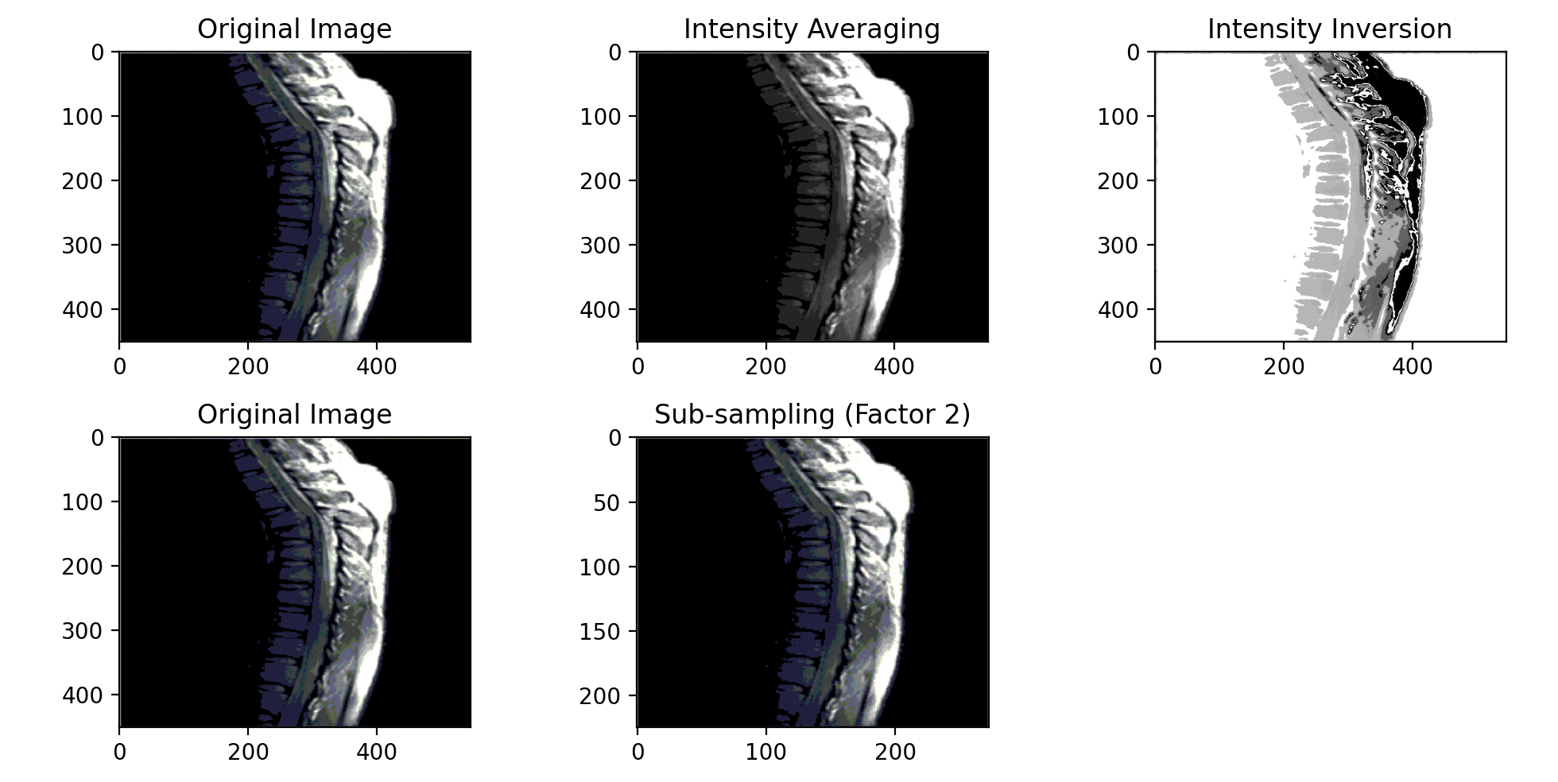

Solution 2:

*import* matplotlib.pyplot *as* plt

*import* matplotlib.image *as* mpimg

*import* numpy *as* np

def contrast_stretching(*image_array*):

*# Minimum and maximum pixel values*

min_val = np.min(*image_array*)

max_val = np.max(*image_array*)

*# Apply contrast stretching formula*

stretched_array = ((*image_array* - min_val) / (max_val - min_val)) * 255.0

*# Clip values to ensure they are within the valid range*

stretched_array = np.clip(stretched_array, 0, 255)

*return* stretched_array

def main():

*# Replace 'input.bmp' and 'input.pgm' with the paths to your BMP and PGM files*

bmp_input_path = 'boats.bmp'

pgm_input_path = 'lungs.pgm'

*# Read BMP file*

bmp_image = mpimg.imread(bmp_input_path)

*# Apply contrast stretching to BMP*

enhanced_bmp = contrast_stretching(bmp_image)

*# Save enhanced BMP using Matplotlib*

plt.imsave('enhanced_bmp_matplotlib.bmp', enhanced_bmp.astype(np.uint8), *cmap*='gray')

*# Display original and enhanced BMP using Matplotlib*

plt.figure(*figsize*=(10, 5))

plt.subplot(1, 2, 1)

plt.imshow(bmp_image, *cmap*='gray')

plt.title('Original BMP')

plt.subplot(1, 2, 2)

plt.imshow(enhanced_bmp, *cmap*='gray')

plt.title('Enhanced BMP')

plt.show()

*# Read PGM file*

pgm_image = np.loadtxt(pgm_input_path, *skiprows*=3)

*# Apply contrast stretching to PGM*

enhanced_pgm = contrast_stretching(pgm_image)

*# Save enhanced PGM using Matplotlib*

plt.imsave('enhanced_pgm_matplotlib.pgm', enhanced_pgm.astype(np.uint8), *cmap*='gray', *format*='pgm')

*# Display original and enhanced PGM using Matplotlib*

plt.figure(*figsize*=(10, 5))

plt.subplot(1, 2, 1)

plt.imshow(pgm_image, *cmap*='gray')

plt.title('Original PGM')

plt.subplot(1, 2, 2)

plt.imshow(enhanced_pgm, *cmap*='gray')

plt.title('Enhanced PGM')

plt.show()

*if* __name__ == "__main__":

main()

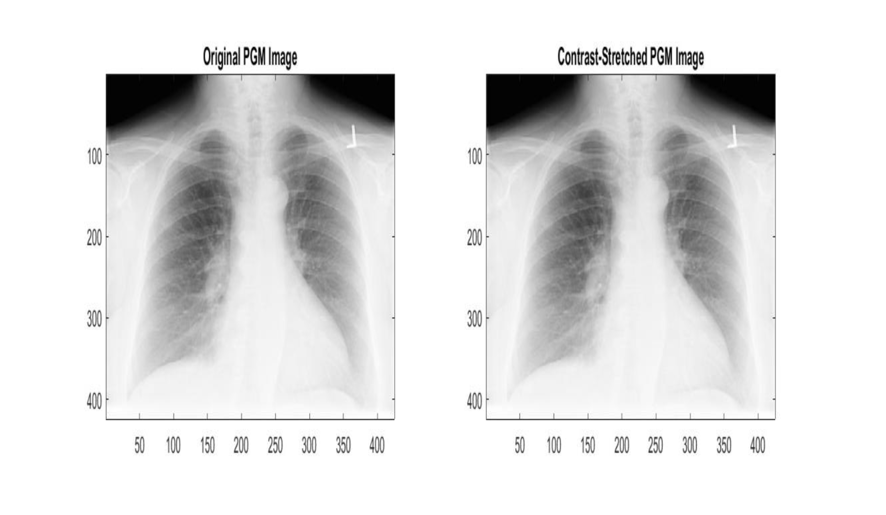

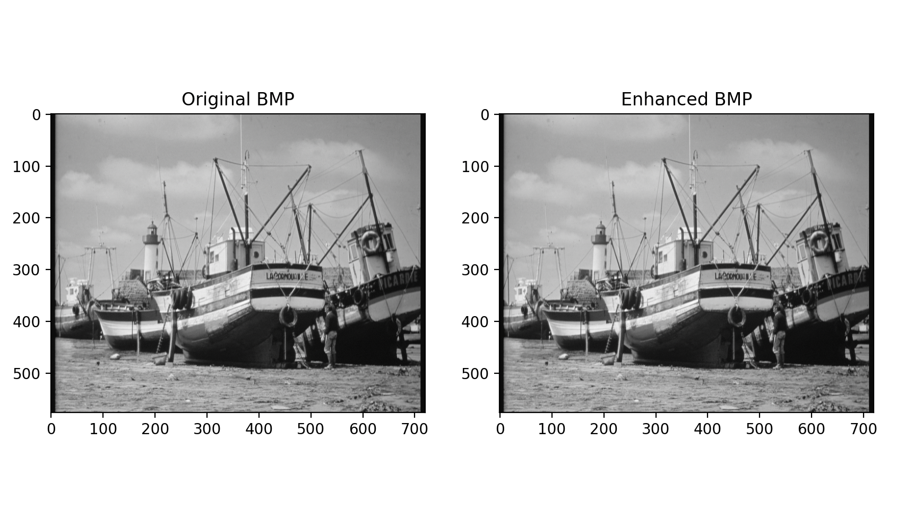

(b)

*from* PIL *import* Image

*import* numpy *as* np

*import* matplotlib.pyplot *as* plt

def log_transform_bmp(*image*):

*# Convert BMP image to numpy array*

img_array = np.array(*image*)

*# Add a small constant to avoid taking the log of zero*

transformed_array = np.log1p(img_array)

*# Normalize to the range [0, 255]*

transformed_array = (transformed_array / np.max(transformed_array)) * 255.0

*# Convert back to uint8*

transformed_array = transformed_array.astype(np.uint8)

*# Create a new Image object from the transformed array*

transformed_image = Image.fromarray(transformed_array)

*return* transformed_image

def main_bmp():

*# Replace 'input.bmp' with the path to your BMP file*

bmp_input_path = 'boats.bmp'

*# Read BMP file*

bmp_image = Image.open(bmp_input_path)

*# Apply log transform to BMP*

transformed_bmp = log_transform_bmp(bmp_image)

transformed_bmp.save('transformed_bmp_log.bmp')

plt.figure(*figsize*=(10, 5))

plt.subplot(1, 2, 1)

plt.imshow(bmp_image, *cmap*='gray')

plt.title('Original BMP')

plt.subplot(1, 2, 2)

plt.imshow(transformed_bmp, *cmap*='gray')

plt.title('Transformed BMP (Log)')

plt.show()

*if* __name__ == "__main__":

main_bmp()

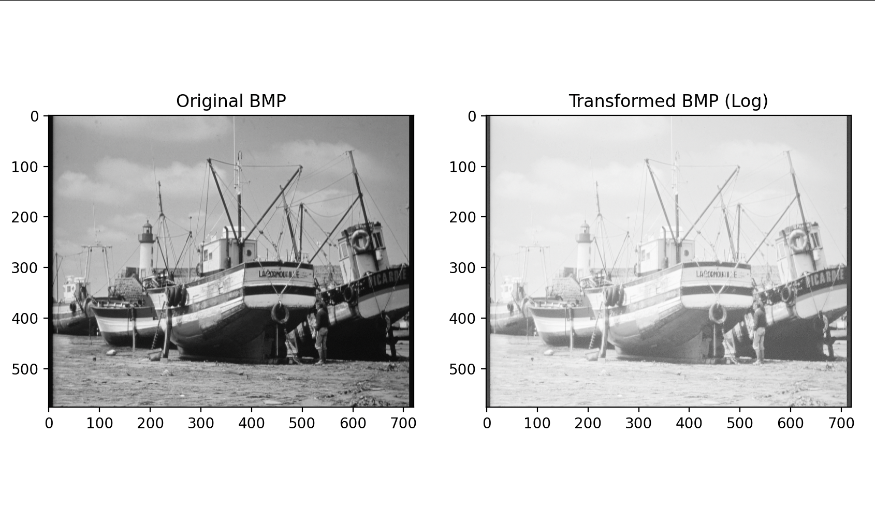

*import* matplotlib.pyplot *as* plt

*import* numpy *as* np

def log_transform_pgm(*image_array*):

*# Add a small constant to avoid taking the log of zero*

transformed_array = np.log1p(*image_array*)

*# Normalize to the range [0, 255]*

transformed_array = (transformed_array / np.max(transformed_array)) * 255.0

*return* transformed_array

def main_pgm():

*# Replace 'input.pgm' with the path to your PGM file*

pgm_input_path = 'lungs.pgm'

*# Read PGM file*

pgm_image = np.loadtxt(pgm_input_path, )

*# Apply log transform to PGM*

transformed_pgm = log_transform_pgm(pgm_image)

*# Save transformed PGM using Matplotlib*

plt.imsave('transformed_pgm_log.pgm', transformed_pgm.astype(np.uint8), *cmap*='gray', *format*='pgm')

*# Display original and transformed PGM using Matplotlib*

plt.figure(*figsize*=(10, 5))

plt.subplot(1, 2, 1)

plt.imshow(pgm_image, *cmap*='gray')

plt.title('Original PGM')

plt.subplot(1, 2, 2)

plt.imshow(transformed_pgm, *cmap*='gray')

plt.title('Transformed PGM (Log)')

plt.show()

*if* __name__ == "__main__":

main_pgm()

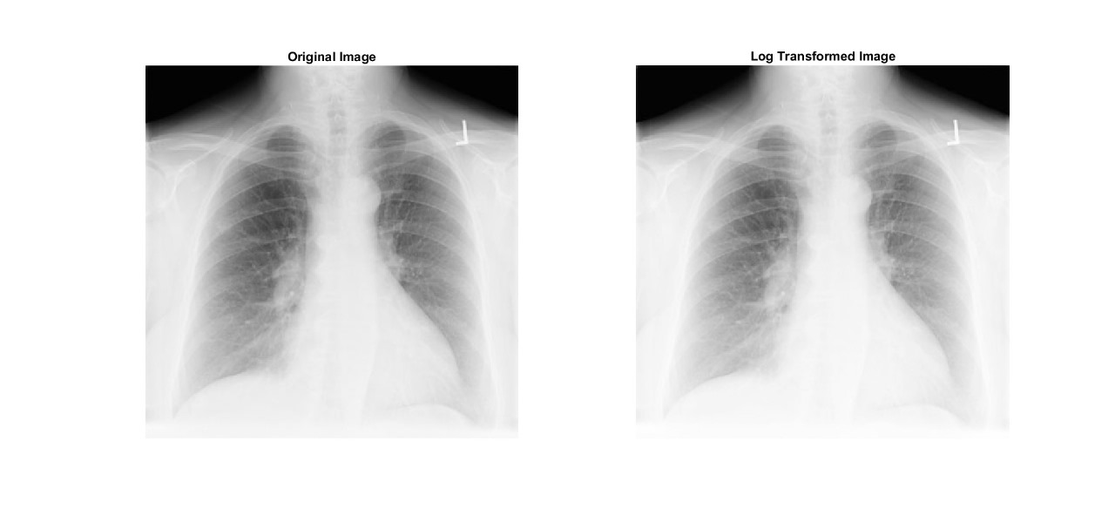

(c)

*from* PIL *import* Image

*import* numpy *as* np

*import* matplotlib.pyplot *as* plt

def power_law_transform_bmp(*image*, *gamma*):

*# Convert BMP image to numpy array*

img_array = np.array(*image*)

*# Normalize pixel values to the range [0, 1]*

normalized_array = img_array / 255.0

*# Apply power-law transform*

transformed_array = np.power(normalized_array, *gamma*)

*# Scale back to the range [0, 255]*

transformed_array = (transformed_array * 255).astype(np.uint8)

*# Create a new Image object from the transformed array*

transformed_image = Image.fromarray(transformed_array)

*return* transformed_image

def main_bmp():

*# Replace 'input.bmp' with the path to your BMP file*

bmp_input_path = 'MRIspineFracture.bmp'

*# Read BMP file*

bmp_image = Image.open('MRIspineFracture.bmp')

*# Set the gamma value (adjust as needed)*

gamma = 1.5

*# Apply power-law transform to BMP*

transformed_bmp = power_law_transform_bmp(bmp_image, gamma)

transformed_bmp.save(f'transformed_bmp_power_law_gamma_{gamma}.bmp')

*# Display original and transformed BMP using Matplotlib*

plt.figure(*figsize*=(10, 5))

plt.subplot(1, 2, 1)

plt.imshow(bmp_image, *cmap*='gray')

plt.title('Original BMP')

plt.subplot(1, 2, 2)

plt.imshow(transformed_bmp, *cmap*='gray')

plt.title(Transformed BMP (Gamma={gamma})')

plt.show()

*if* __name__ == "__main__":

main_bmp()

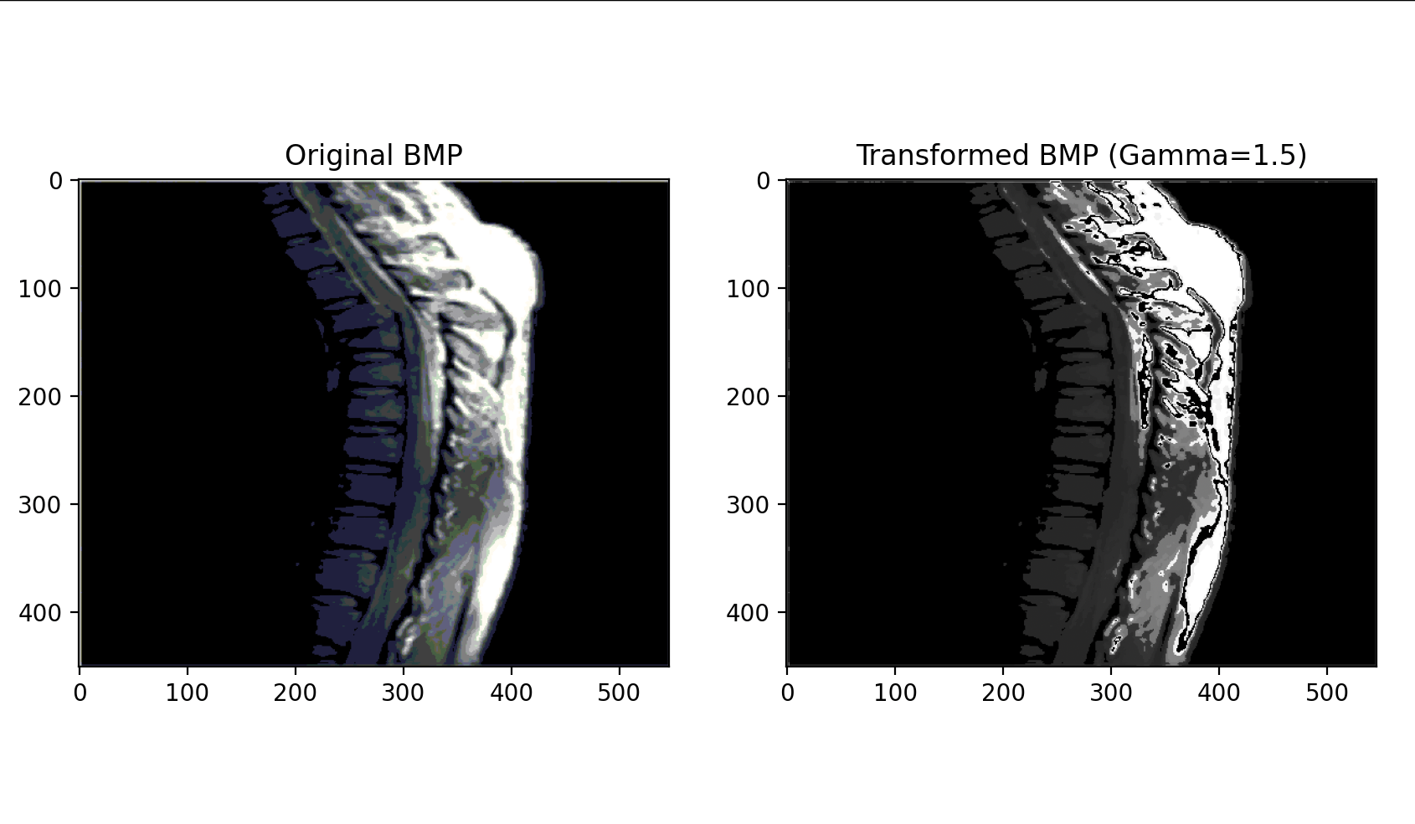

*import* matplotlib.pyplot *as* plt

*import* numpy *as* np

def power_law_transform_pgm(*image_array*, *gamma*):

*# Normalize pixel values to the range [0, 1]*

normalized_array = *image_array* / np.max(*image_array*)

*# Apply power-law transform*

transformed_array = np.power(normalized_array, *gamma*)

*# Scale back to the range [0, 255]*

transformed_array = (transformed_array * 255).astype(np.uint8)

*return* transformed_array

def main_pgm():

*# Replace 'input.pgm' with the path to your PGM file*

pgm_input_path = 'lungs.pgm'

*# Read PGM file*

pgm_image = np.loadtxt('lungs.pgm', )

*# Set the gamma value (adjust as needed)*

gamma = 1.6

*# Apply power-law transform to PGM*

transformed_pgm = power_law_transform_pgm(pgm_image, gamma)

*# Save transformed PGM using Matplotlib*

plt.imsave(f'transformed_pgm_power_law_gamma_{gamma}.pgm', transformed_pgm.astype(np.uint8), *cmap*='gray', *format*='pgm')

*# Display original and transformed PGM using Matplotlib*

plt.figure(*figsize*=(10, 5))

plt.subplot(1, 2, 1)

plt.imshow(pgm_image, *cmap*='gray')

plt.title('Original PGM')

plt.subplot(1, 2, 2)

plt.imshow(transformed_pgm, *cmap*='gray')

plt.title(f'Transformed PGM (Gamma={gamma})')

plt.show()

*if* __name__ == "__main__":

main_pgm()

